**ERP-Tag migration using ACMP Tool**

ACMP is an oracle tool to perform ERP Apps – Build and deployment activates.

Below are build and deployment steps:

1. Check the tag dependencies
2. Create ACMP Package
3. Install / Deploy ACMP Package in instance like DEV / CQT/ LAT/CAT/ PROD ( need to perform pre-installation, installation, post installation steps based on MD120 doc)
4. Check deployment Log
5. Enter the Tag information in COMATRA
6. Upload the ACMP Package in SVN
7. Change deployment status in ACMP tool
8. Send E-Mail notification to Developer

**Example:**

Tag: OM001_v03.04.00_6_20171205_FOP-24111

<https://subversion.michelin.com/fop/mich_ont/OM001_GCS_E_OMGLOBALPKG/tags/OM001_v03.04.00_6_20171205_FOP-24111>

Pre Build – Check list:

|  |  |
| --- | --- |
| **Tag Name** | **Dependencies** |
| OM001_v03.04.00_6_20171205_FOP-24111 | NA |
| OM001_v03.04.00_5_20170906_FOP-19625 | NA |
| OM001_v03.00.00_2_20170905_FOP-23481 | NA |
| OM001_v03.00.00_1_20170905_FOP-23481 | NA |
| OM001_v03.00.00_4_20170905_FOP-23481 | NA |

Build Process:

MD120 doc:

| Sr. No. | File Name | Type | Version | Source Location | Target Location |
| --- | --- | --- | --- | --- | --- |
|  |  |  |  |  |  |
| 1 | MICH_OEXOEORD_FP.ldt | LDT | 1 | <BASE_LINE>  \05_impl\0_src\install | patch/115/import/US |

Build and Deployment Manger tabs in ACMP:

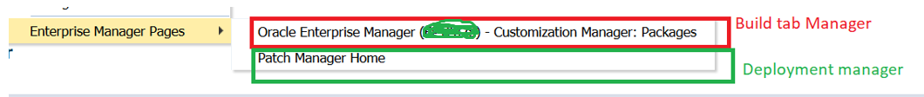

ACMP package creation configuration:

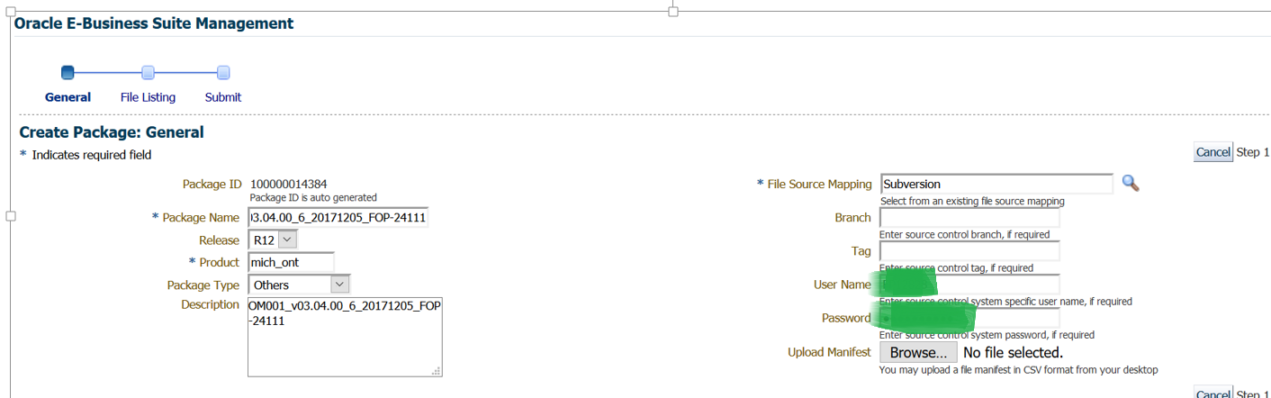

Step 2:

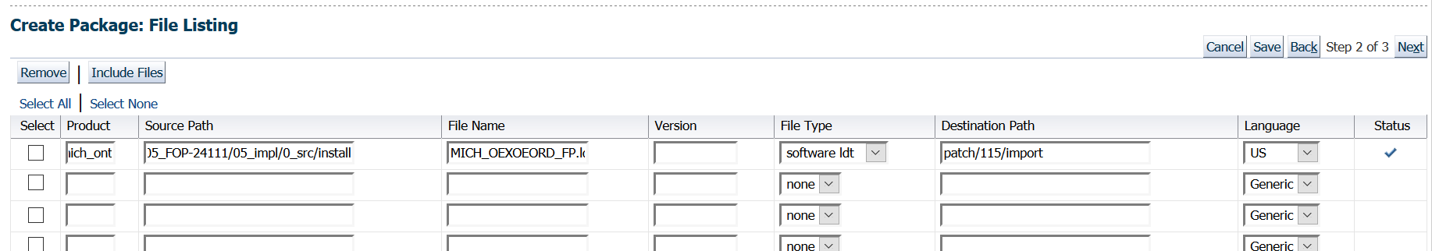

Step 3:

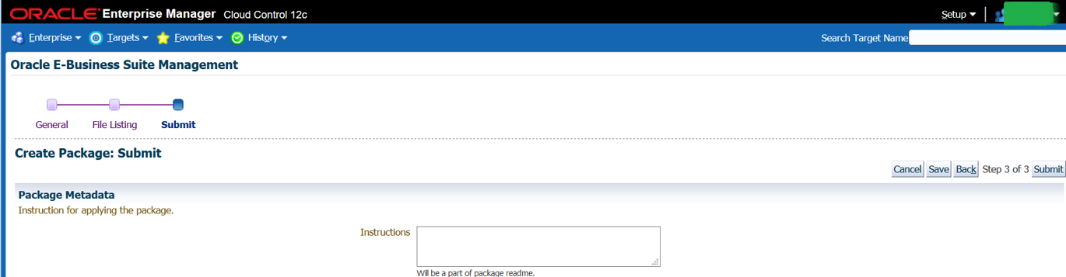

Step 4: Build completed

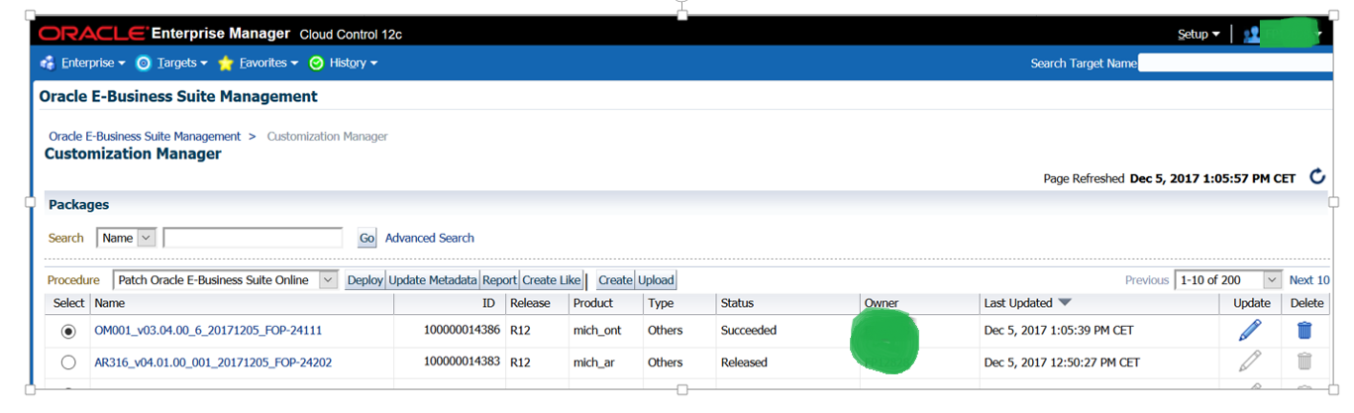

**Deployment process:**

Step 1.

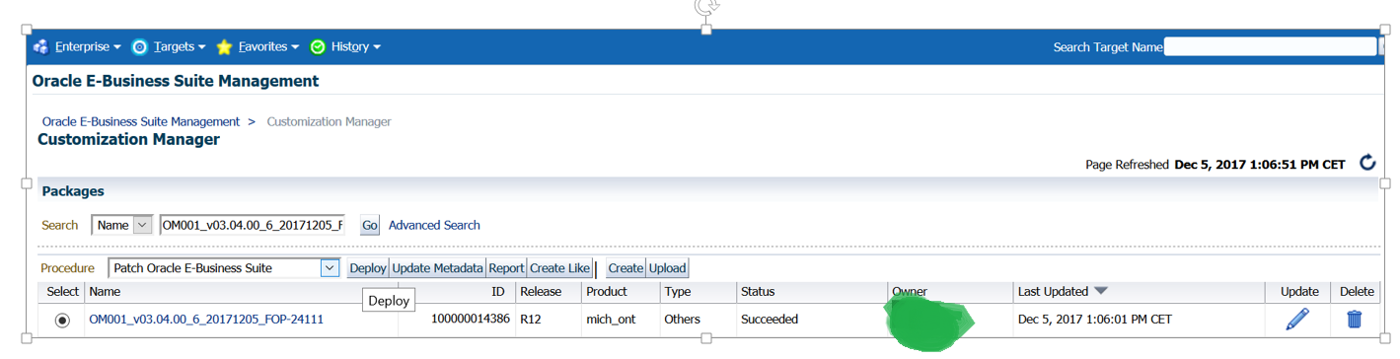

Step 2: Deploying binary in CQT 12.1.3 instance

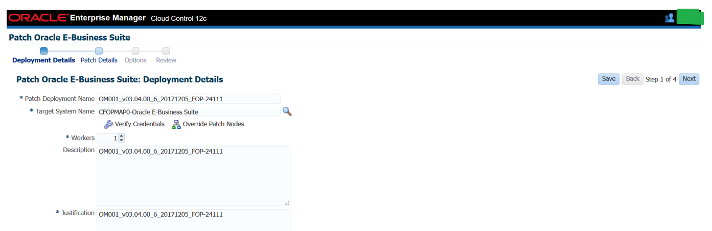

Step 3:

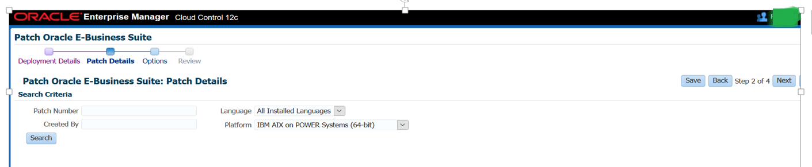

Step 4:

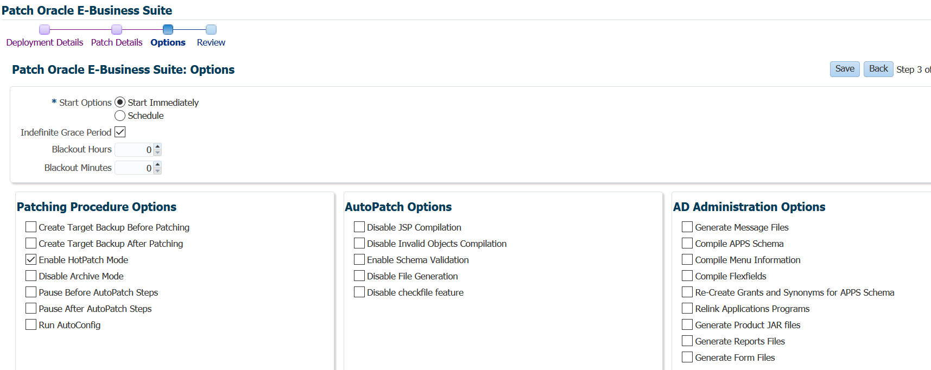

Step 5:

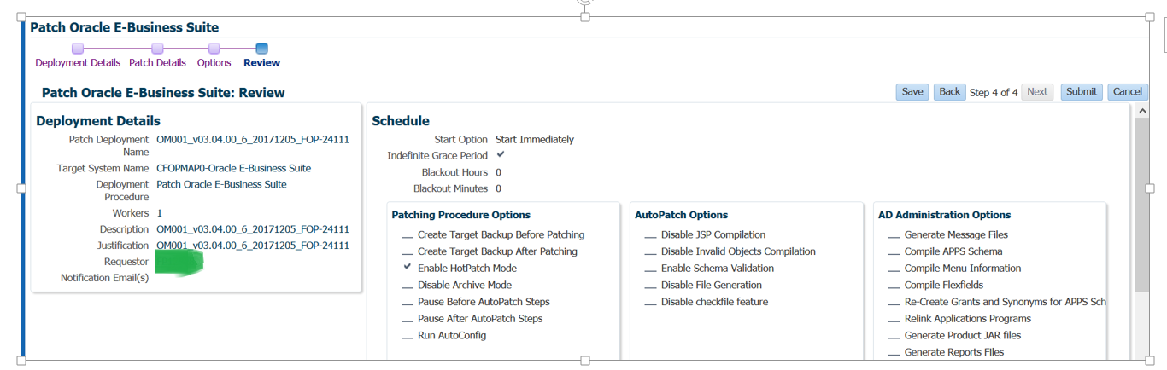

Step 6:

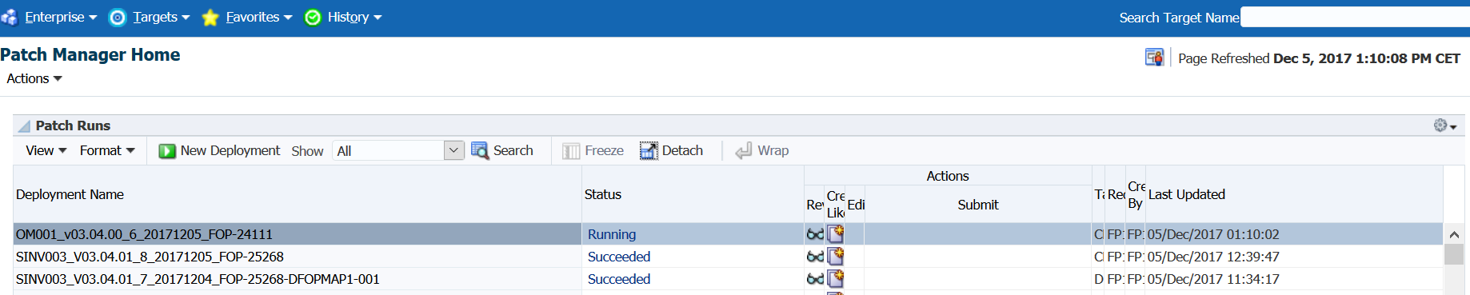

Step 7: After deployment need to check the deployment log : adworkers log file in unix box.

$ tail -1500 $APPL_TOP/admin/CFOPMAP0/log/adwork001.log

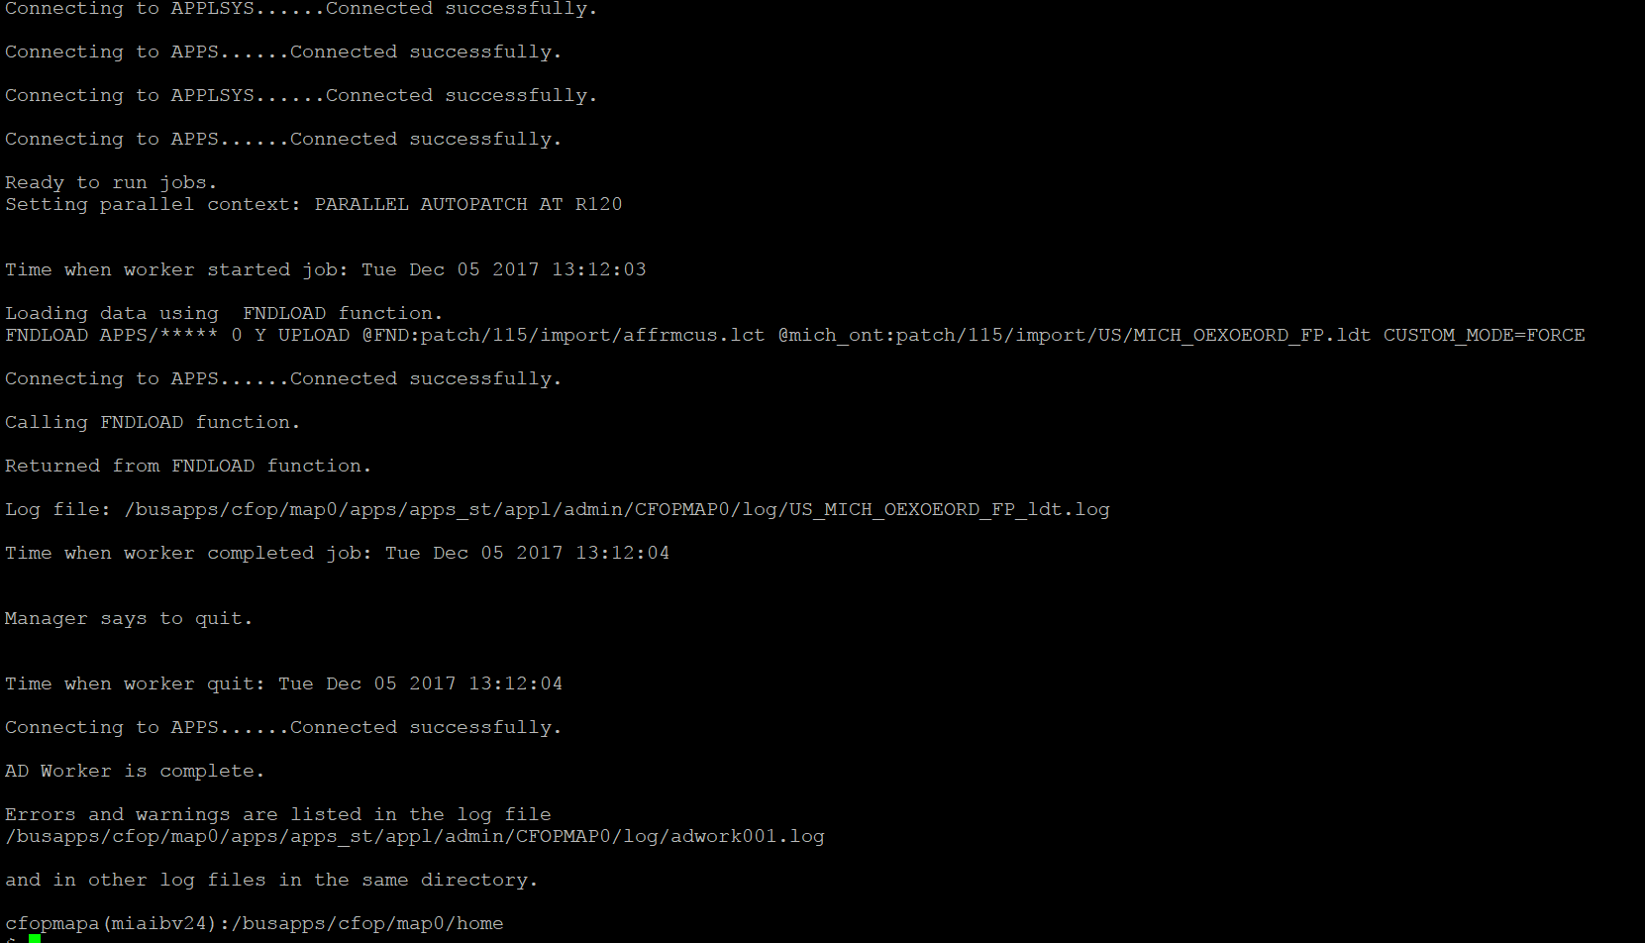

Hence deployment has been completed.

**Update the data in COMATRA:**

Step1:

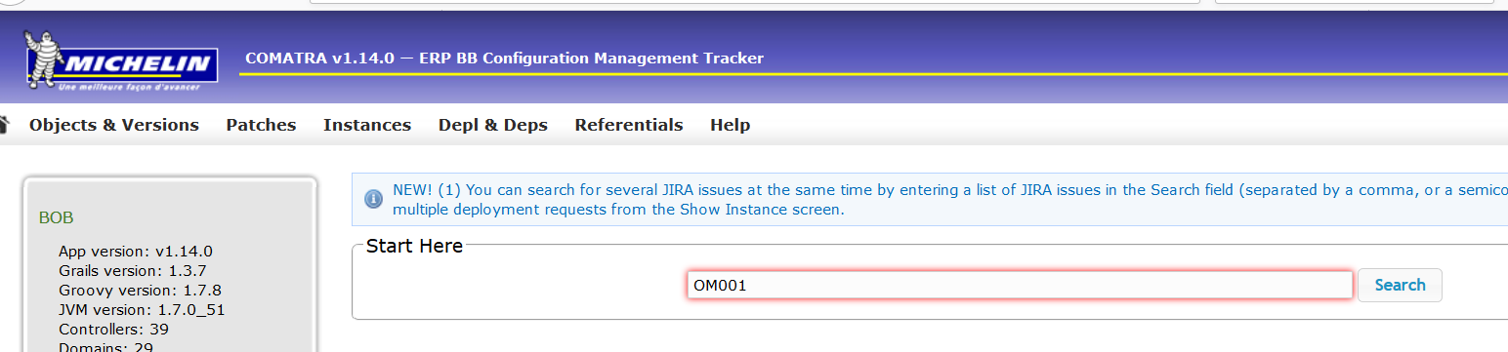

Step 2:

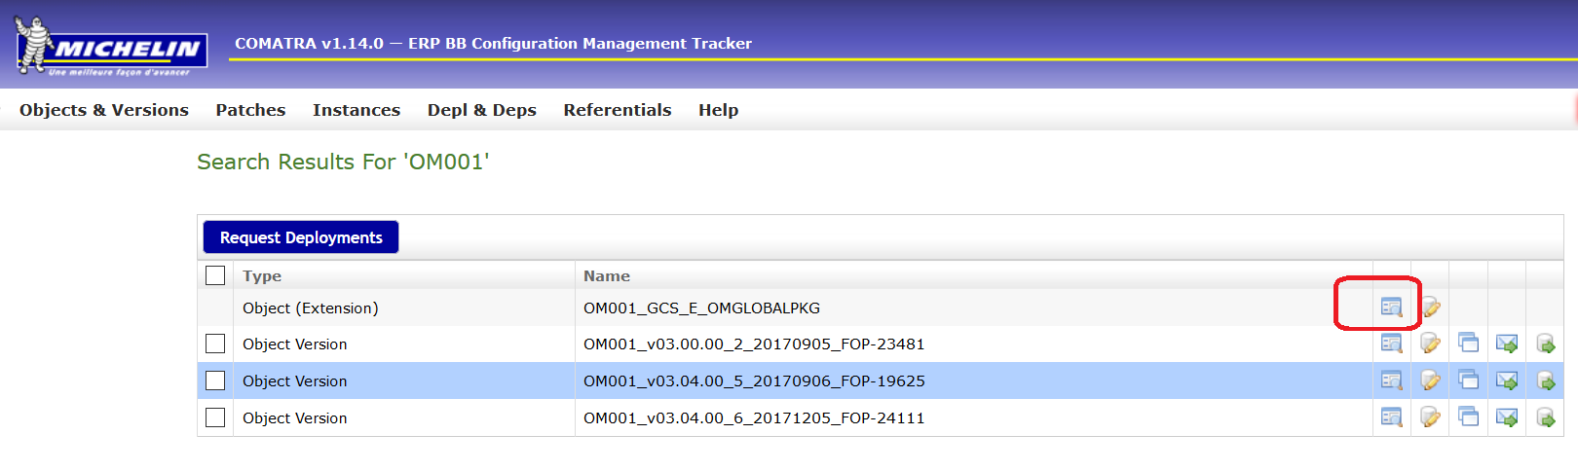

Step 3:

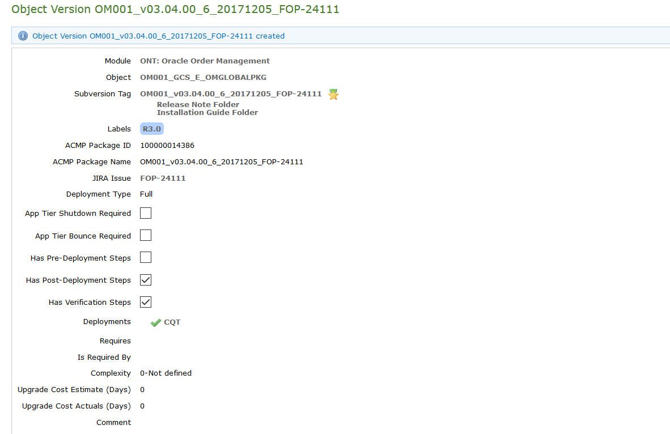

Enter the above details and Save it.

**Upload Binary file in SVN tag:**

Step1:

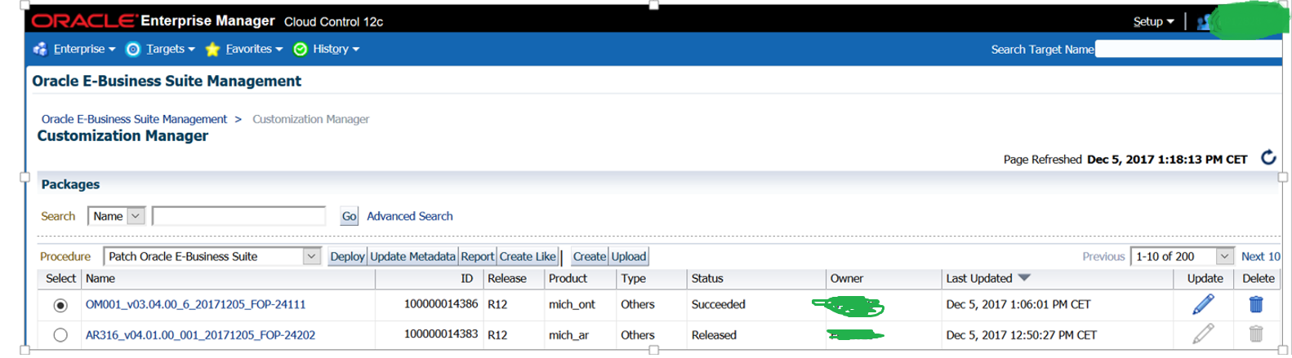

Step 2:

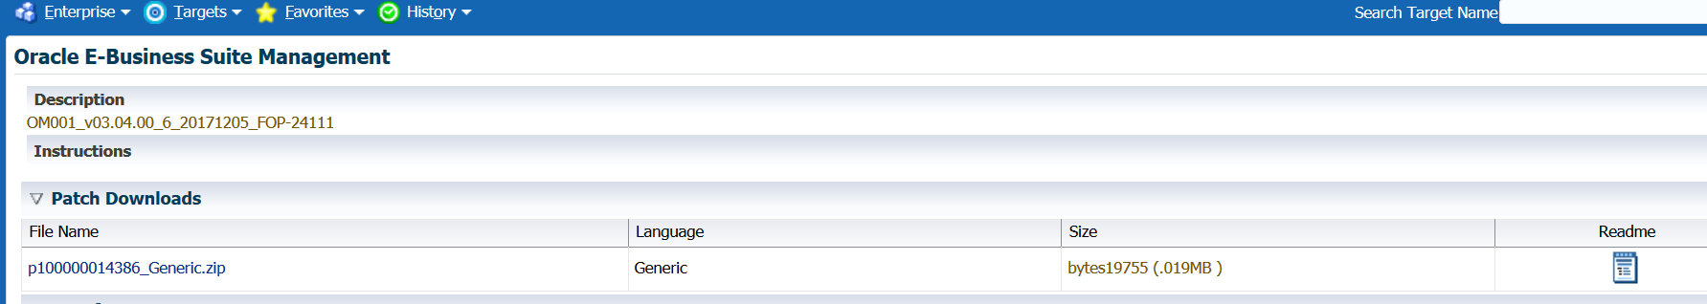

Step 3:

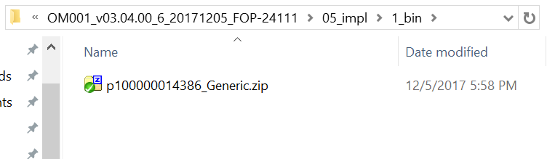

Uploaded Binary file in SVN

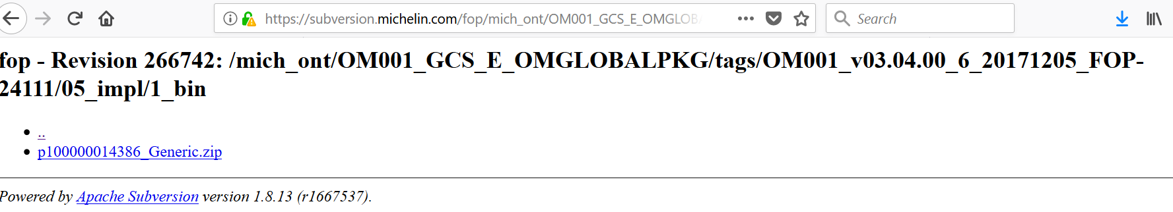

Change the status in ACMP:

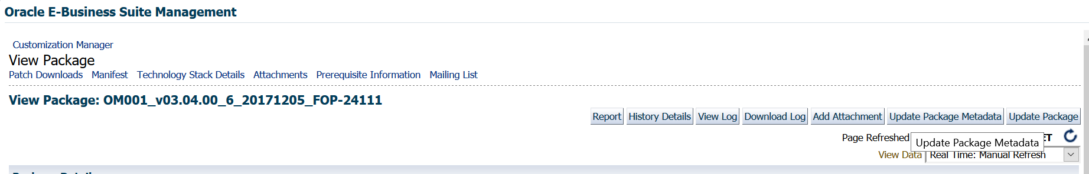

Step 2:

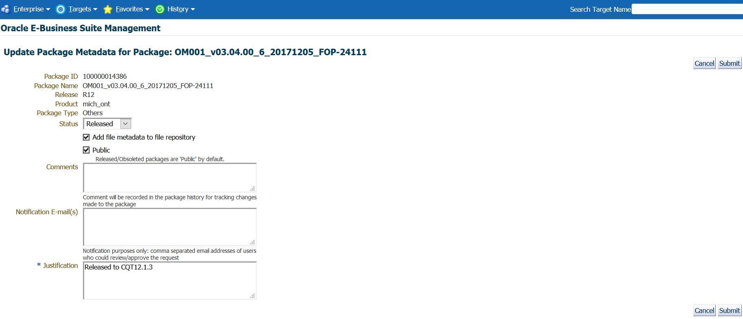

Click on submit.

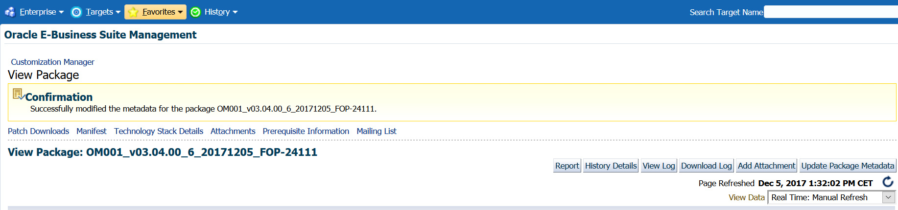

Check the build status:

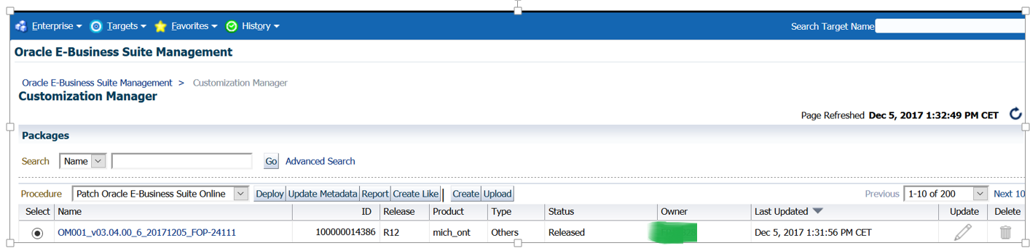

Send the email notification to Dev Team.

-------------------------- The End ------------------------------------------